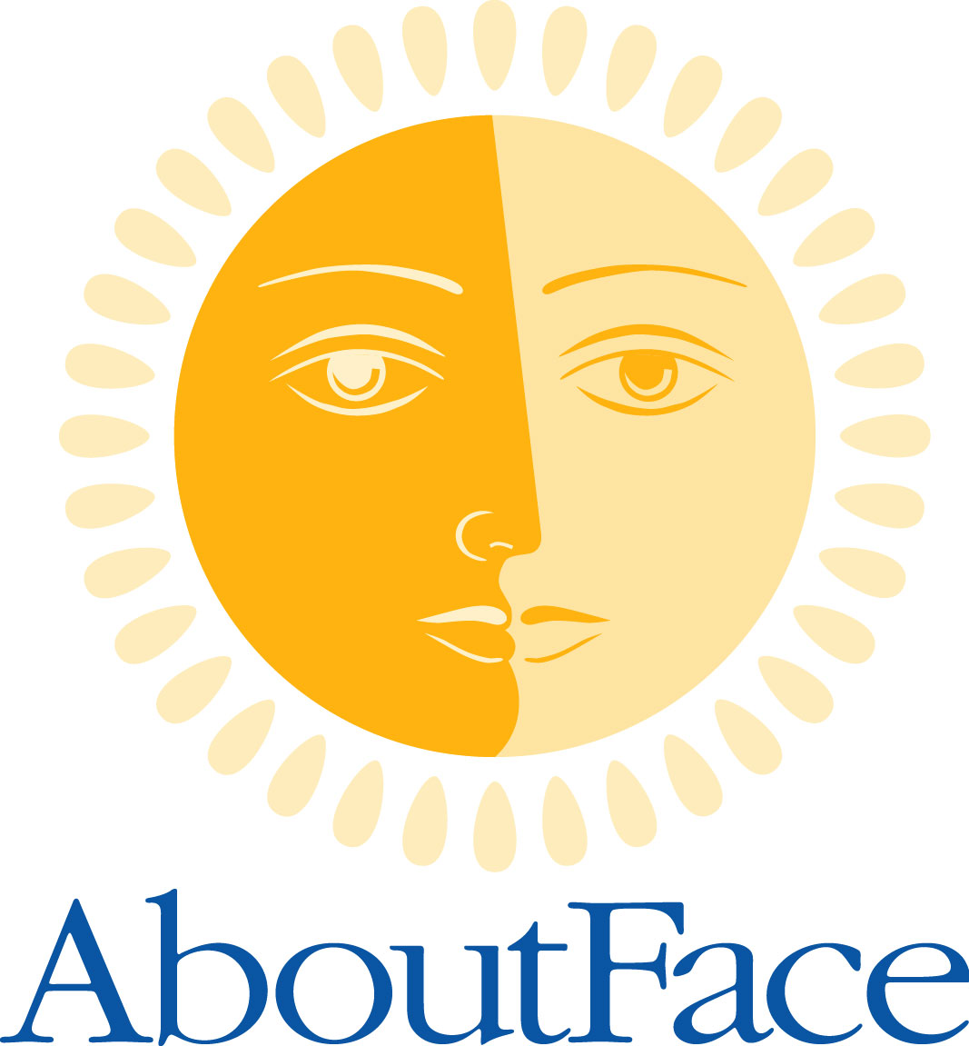
AboutFace USA
P.O. Box 158
South Beloit, IL 61080-00158
(888) 486-1209
www.aboutfaceusa.org

FACTS & INFORMATION

Inspiration

- AboutFace USA is a national organization, providing information and support for persons with facial differences and their families. Thousands of families make contact with us every month, via telephone, e-mail and our websites.

- AboutFace USA supports people whose facial differences are present at birth, such as cleft lip and palate, Treacher Collins, Hemangiomas, Moebius, and other conditions and syndromes. Support is also available for those whose facial differences were developed or acquired as a result of illness, disease or trauma.

- AboutFace USA provides access to a broad range of written and audio-visual information about various craniofacial conditions. Community-based resources can also be provided to help families adapt to the effects and challenges of living with a craniofacial condition/facial difference. A school program is also available.

- AboutFace USA provides individuals and families an opportunity to connect with others facing similar challenges through the Pathfinder Outreach Network.

Education

- Media Outreach – Newspaper and magazine articles, public service announcements and special events raise public awareness about the causes and treatment of craniofacial anomalies.

- Healthcare Professionals – While promoting family-centered care and always stressing the importance of a team approach to craniofacial treatment, AboutFace USA provides in-service presentations to students, teams and other medical staff who feel they can benefit from understanding the patient and family point-of-view.

- Medical Conferences and Tradeshows – Reaching out by presenting and exhibiting at appropriate trade shows and conferences, AboutFace USA builds relationships with medical and other professionals, encouraging them to refer patients, request information and become volunteers.

Support

- The Pathfinder Outreach Network – The national Pathfinder database is the foundation for networking individuals by region, condition, age or procedure. Services include newborn outreach and emotional support for parents to provide a better understanding of the needs of children with craniofacial anomalies. Adult and teen peer counseling is also available. In addition, families stay in touch through our interactive forum, The Family-to-Family Connection.

- Newsletter – Highlighting personal stories of challenge and triumph, as well as various regional and national resources, the AboutFace USA newsletter reaches thousands of families via mail and the internet several times each year.

- Websites –Timely information and national resource contacts can be found at our websites at www.aboutfaceusa.org and www.cleftadvocate.org. Links to various support organizations are provided for those needing to connect with additional services. Special announcements as well as the most recent newsletter are published on these sites.

- The North American Craniofacial Family Conference (NACFC) – Bringing individuals and families together with healthcare and other professionals, the NACFC will continue to provide the very best in educational and social opportunities for the craniofacial community. Parents, patients, siblings and friends are encouraged to attend the annual event.

