Mean Girls!

Gossip
Backstabbing
Emotional Bullying
Teasing to hurt
Lies
Eye-rolling
Secrets
Sarcasm
Silent Treatment
DRAMA
Name Calling
Rumors
Relational
Aggression

Have you ever seen kids:
- Gossiping about other girls?
- Excluding other kids?
- Teasing in order to hurt people’s feelings?
- Ganging up on one another?
Most kids see it every day but they
don’t know what it’s called.
Its name is:
RELATIONAL AGGRESSION!

Read these stories and see if you have you ever experienced anything like this:
”Once, one of my friends called me and while we
were talking, she asked me if I liked Christina,
one of the girls in our class. I said I didn’t.
Then I heard a click. I had forgotten that my friend had three-way calling.
Next, I heard Christina on the other line telling my friend that she didn’t like me either!
The following day, on the playground after lunch, Christina and my friend were playing and ignoring me, and my friend didn’t want to be my friend any more.
Now I’m scared to talk with people on the
phone because I always wonder if people will try to trick me into saying something bad about
somebody who’s listening to our conversation!”



”They were the popular girls. Whenever a new girl came into the school, Courtney, Stacy and Madison would act really nice to her and invite her to sit with them at lunch and on the bus. They would gossip about other girls and encourage the new girl to tell them personal things and secrets about herself.
Then, once she felt like she was a part of their group, they’d talk about her behind her back. If they decided they didn’t like her, they’d start telling other people her personal business. They would make fun of her and “freeze her out.”
When she’d try to sit with them at lunch, they’d say, “We’re saving this seat for Brittany; you can’t sit with us.” By then, the other girls didn’t want to sit with her either; they thought she must be a snob, like Madison, Stacy, and Courtney.”
“It was bad enough to have to dissect a fetal pig. It
was even worse that when Julia’s science teacher divided the class into lab groups, he put Julia in a
group with Kady, Yolanda, and Shanequa. Julia didn’t know them very well.
At first they just ignored her and talked only
to one another. Then they started rolling their eyes whenever she said something. They would ignore her suggestions and make fun of her work. She wanted to do a good job in lab, but no matter how good her ideas were, they wouldn’t listen to her. She felt alone and discouraged, like she wasn’t worth other people’s attention.
After school one day, when no adult was around, they kicked her locker closed and pushed her away. Julia thought they hated her because she wasn’t African-American. She started getting a headache every day before school and wishing that she could stay home from school.”
”Annie hated being overweight. What she hated most was the way other girls treated her. They’d say her clothes didn’t fit right. Some people said she smelled. A few of the meaner girls would make “fat jokes” behind her back. When other kids laughed, they’d start making jokes right to her face.
Annie wanted to lose weight but she just couldn’t seem to do it. She felt that nobody liked her. What she wanted more than anything was a friend or two to hang out with, to go shopping with, and to be invited to their parties. She felt that she could be a really good friend to somebody if anybody ever gave her the chance. But the way she was treated made her feel alone and unwanted.”
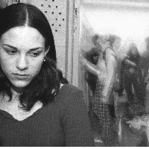

TEASING HURTS!
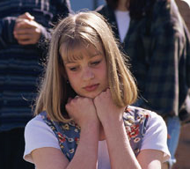
If you’ve ever felt like one of these girls, don’t worry, because you are not alone! Every girl you know, no matter how popular she seems, deals with these issues as a pre-teen and teen.
Even your mom and your teachers remember times when other girls were mean to them, or when they were mean to another girl!
Sometimes, there’s a clique of girls who act as though they’re better than everybody else.
Sometimes, a few girls may ignore or talk about someone who has been their friend.
Sometimes people may pick on someone because she’s of a different race or religion, or came from a different school, or even because she’s smart or not so smart, or she’s overweight or she’s thin….
Have you seen these examples of relational aggression?
* Name-calling
* Giving someone the “silent treatment” or
leaving her out
* Telling another girl’s secrets or passing along rumors that are already being spread
* Teasing in order to hurt someone
* Rolling their eyes when somebody talks
* Not allowing other girls to sit with them
at lunch or at special events
* Using sarcasm to hurt someone’s feelings
* Using put-downs of any kind
* Cliques – groups that won’t let others in
* Trying to get girls to side with them
against another girl
* Using IM or MySpace to post negative things
about others; it’s called “cyber-bullying”
* Acting tough

Why Does This Happen?
Girls often act mean
not because they feel bad about YOU, but because they feel bad
about themselves.

Fear and insecurity are
the causes of
relational aggression.

* People who bully are insecure. They
worry about remaining “on top,” so
they try to control other people.

* Girls who are victims of bullying often
lack confidence in themselves. So they
may accept the bullying because they
feel that somehow, they deserve it,
or they’re afraid to fight back.

* Girls who stand by and watch other girls
get bullied are afraid to step in because
they’re worried that the bully will make
them her next target.

What can you do
when girls turn mean?
When you are the target of mean behavior by another girl (or girls), you have lots of choices about how to react. Some may work in one situation and not in others. If one doesn’t work, try another!
* Try to ignore them, so they can see that their meanness isn’t getting a rise out of you.
* Stay away from places – a hallway, a lunch table, a locker bay – where harassment happens.
* Have a safe place to go when you’re afraid.
* Record your feelings and thoughts in a journal.
* Speak up for yourself and tell the aggressors to stop doing it!
* Ask a friend to tell the mean girls to stop.
* Ask the bullies: “What good is this doing for you? If you aren’t getting anything good from being mean, then why do it?”
* Say: “Everybody’s different but everybody’s equal.”
* Tell them: “You hurt my feelings. I don’t like that. It’s fine if you don’t want to hang out with me; I’ll hang out with someone else.”
* Remind them, “The way you treat me is the way other people will treat you. What you send out comes back to you.”
* Ask your mom or other older women to tell you about their experiences with relational aggression.
* Get to know older girls who understand and who can speak up for you.


* If somebody’s making fun of you, don’t
laugh it off, get defensive, or start crying.
* Keep in mind that the “queen bees” have troubles of their own.
* If things get really bad in a class or at lunch, ask the counselor to change your schedule.
* When you see somebody teasing or bullying, point it out. Call it by its right name. Say, “That’s mean!”
* Concentrate on doing the things you enjoy and developing your skills.
* Get involved in community service; it makes you feel better about yourself.
* Get to know people in activities outside of school.
There are things you can do to protect yourself from mean girls!
Some other things to think about:

~~ If girls tease you because they say you need deodorant or you wear too much makeup, is it possible that they have a point? Even if their tone is unfriendly, maybe you could learn something helpful!
~~ If what they’re saying is unfair, then are you letting them affect you when you shouldn’t? If girls make cutting remarks because they are jealous of you, then they are the ones with the problem, not you!
~~ You aren’t the only one who worries about your friendships. Every girl does!
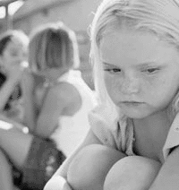

But remember, EVERYBODY’s tempted to act mean to others at one time or another!
SO HOW ABOUT YOU?
Take this quiz to see if you have ever bullied anyone, even if you didn’t do it on purpose:
* Have you ever started a rumor about someone, whether it was talking about them, saying it in a note, IMing it, or putting it in an e-mail?
□ Yes □ No
* Have you or your friends excluded a girl from hanging out with you at lunch, from playing with you at recess or in sports, when inviting people to a party, or to be in other clubs or activities?
□ Yes □ No
* Have you ever teased anyone by calling her names or making fun of the way she acts, dresses, or talks?
□ Yes □ No
* Have you been part of a group that did any of these things, even if it wasn’t your idea, but you were just going along with other people?
□ Yes □ No
* Have you ever heard other kids saying bad things about a girl’s race or religion or background, but you didn’t object because you didn’t want the other kids to be mad at you?
□ Yes □ No
If you said YES to any of these questions, you don’t need to feel terrible, because EVERYBODY has done these things at least once!
BUT WE NEED TO MAKE IT STOP…

BECAUSE EMOTIONAL BULLYING HURTS PEOPLE!
It hurts the girls who are bullied, and it hurts the girls who bully them.
- It makes girls feel depressed and lonely.
- Kids who bully are more likely to get into trouble and drop out of school.
- They are more likely to get involved in
substance abuse and eating disorders.
- It sets up habits that can continue
when girls become adults.
- So we need to take it seriously! Some adults say that it’s “just the way kids act,” so there’s no point trying to make things better.
- But IT DOESN”T HAVE TO BE THAT WAY!
Do you ever stand by while other girls make fun of somebody?
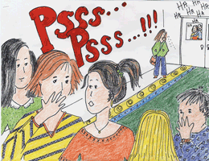

Maybe you feel that as long as you don’t say anything mean, you aren’t causing a problem. But if you were the one being teased or bullied, would you want the other girls to just stand by and watch?

* If you see a friend putting somebody down, step in and stop it!
* When girls start to badmouth someone, just walk away.
* When somebody else is being mean, you could say, “Brittany, quit doing that. Nobody thinks it’s cool.”

* When you see somebody being excluded or teased, be a friend to her. Sit and talk with her at lunch. Show her that you care how she feels.
* Remember not to gang up on anyone. Just because you’re mad at somebody doesn’t mean that you should try to get your friends mad that person too. Give your friends the space to have their own friends and their own opinions. If you’re the only one who likes a particular girl, that’s OK!
* Change the gossip from negative to positive: When you hear other girls saying something mean about someone, say something you like about somebody else!
****Make everyone feel welcome! ****
Do you have friends who will stand up for you?

Teen and pre-teen girls need friends. But they need REAL friends!
Think about the girls you hang out with. Can you trust them with your secrets? Do they keep your personal business to themselves?
Do they really care about you? Are they glad when good things happen to you, or do they seem jealous?
Sometimes we spend time with people we don’t feel comfortable with – maybe because other people think they’re cool or because we’ve gone to school with them for years or because they want to be friends with us.

Ask yourself whether the girls you call your friends will bring you up when you’re down. Do they act in a way that makes you comfortable and proud?
Will they support you if you need help? Would they defend you if somebody tried to bully you or spread rumors about you? Would they speak up if somebody said something bad about you behind your back?
If not, then you need better friends!
Where can you find them?
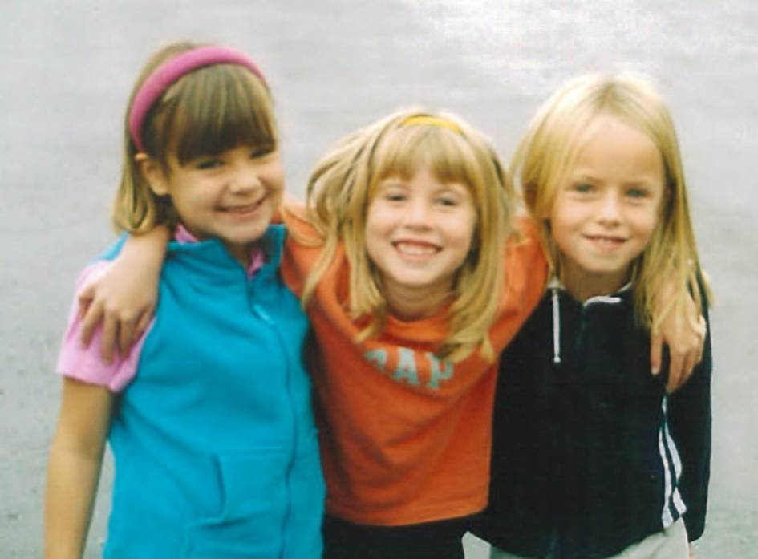

Look around!
Is there a girl you think is kind, thoughtful, and caring, but you just haven’t ever hung out with her? Smile and say hi to her!
Is there a girl in your classes who seems nice but who is shy? Go up and tell her something you like about her!
Is there a girl who seems to be looking for a new friend? Does she seem nice and trustworthy, whether or not she is “cool”?
Is there a girl who shares your interest in music, in sports, or in something else? Talk to her and ask about her interest!
When should you get help?
There are times when you shouldn’t try to handle a problem yourself.
♠ If you think that you are in danger of
getting hit or physically hurt
♠ If you think somebody else is in danger
♠ If other girls make you feel so bad that you are not able to bounce back, or if you feel like you want to hurt yourself
♠ If someone gets physical with you
then you need to talk to an adult.
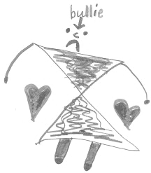

Here’s a list of people you can go to:

* Your mom, dad, aunt or uncle, grandparent, or guardian
* A social worker, counselor, or nurse at school
* A teacher or other adult you trust, such as a nurse or doctor, a coach, a police officer, or a family friend
* A close friend, especially an older friend, who can listen and support you
* Under some circumstances, your parent or the social worker may want to talk to the parent(s) of the girls who are bullying you, or to check with a counselor outside of school.
* If you’re worried about talking to an adult, take a friend with you.
* You aren’t “snitching” when you tell an adult; you’re helping yourself or a friend to set things right.
So here’s the take-home message:
► Everyone deserves to be treated with respect!
► People who are victims of RA can become bullies themselves; don’t let bullying make you want to hurt other girls.
► RA becomes a cycle. The cycle has to be broken. So treat people the way you want them to treat you.
► You won’t always be a teenager, and believe it or not, life gets better as you get older!

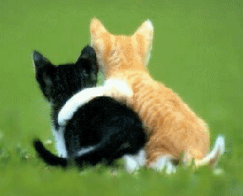
Here are some helpful books, movies, and web sites

Books:
1. Rachel Simmons, Odd Girl Out: The Hidden Culture of Aggression in Girls (Harvest Books, 2003)
2. Rachel Simmons, Odd Girl Speaks Out: Girls Write about Bullies, Cliques, Popularity, and Jealousy (Harvest Books, 2004)
3. Cheryl Dellasega and Charisse Nixon, 12 Strategies That Will End Female Bullying (Fireside, 2003)
4. Judy Blume, Blubber (Yearling, 1976)
5. Gail Carson Levine, The Wish (Harper, 2001)
6. Ron Jones, The Acorn People (Laurel Leaf, 1996)
7. Jerry Spinelli, Stargirl (Knopf, 2002)
8. Jerry Spinelli, Loser (HarperTrophy, 2003)
9. Julia DeVillers, GirlWise: How to Be Confident, Capable, Cool, and in Control (Three Rivers Press, 2002)
10. S. E. Hinton, The Outsiders (Puffin, 1997)
Movies:
“Mean Girls” (2004)
“She’s All That” (1999)
“Never Been Kissed” (1999)
“Odd Girl Out” (Lifetime, 2004)
Resources for parents and teachers:
1. Mary Pipher, Reviving Ophelia: Saving the Selves of Adolescent Girls (Ballantine, 1995)
2. Allan L. Beane, The Bully Free Classroom: Over 100 Tips and Strategies for Teachers K-8 (Free Spirit Publishing, 1999)
3. Barbara Coloroso, The Bully, the Bullied, and the Bystander : From Preschool to High School--How Parents and Teachers Can Help Break the Cycle of Violence (Collins, 2004)
4. Jeanette Gadeberg and Beth Hatlen, Brave New Girls: Creative Ideas to Help Girls Be Confident, Healthy, and Happy (Fairview Press, 1997)
5. Nancy Snyderman and Peg Streep, Girl in the Mirror: Mothers and Daughters in the Years of Adolescence (Hyperion, 2003)
6. Rosalind Wiseman, Queen Bees and Wannabes (Three Rivers Press, 2002)

…. and web sites:
1. Jenn Director Knudsen, “Relational Aggression: Helping the Young Victims of Emotional Bullying,” http://childrentoday.com/resources/articles/ emotionalbullying.htm
2. U. S. Department of Health and Human Services, “Stop Bullying Now!” http://www.stopbullyingnow.hrsa.gov/index.asp?area=main
3. The Ophelia Project, http://www.opheliaproject.org/main/index.htm
4. Club Ophelia, “Relational Aggression,”
http://www.clubophelia.com/aggression/
5. National Association of School Psychologists, “When Girls Become Bullies and Victims: Relational Aggression,” http://www.guidancechannel.com/default.aspx?M=a&index=1741&cat=17

This booklet was researched and written by
Francesca Ossi, with help from Hannah Hershey and Dana Talant. We are grateful to Michelle Martin Colman and The Ophelia Project for their help.
May, 2006
Bloomington, Indiana


